**Neural Networks**

**Gas Turbine Solution:**

* Here the provided is n different units and ranges, so we need to normalise the data first.
* Then after splitting the data and using the neuralnet function with no hidded values, I got a testing accuracy of 99..88% and the following neural network plot:

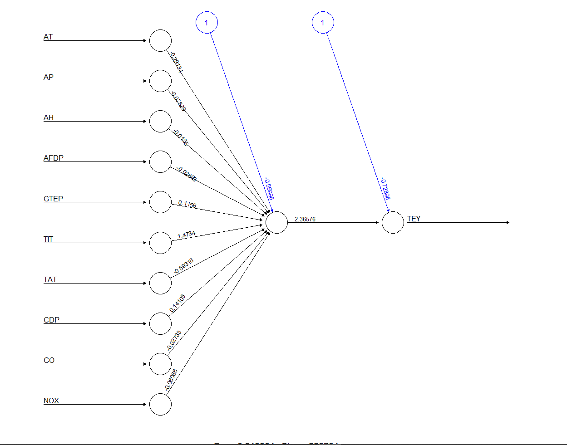

Error = 0.5, steps: 226784

* I later tried using 2 layers of 5 nodes and 3 nodes and got an accuracy of 99.90% and the following neural network plot:

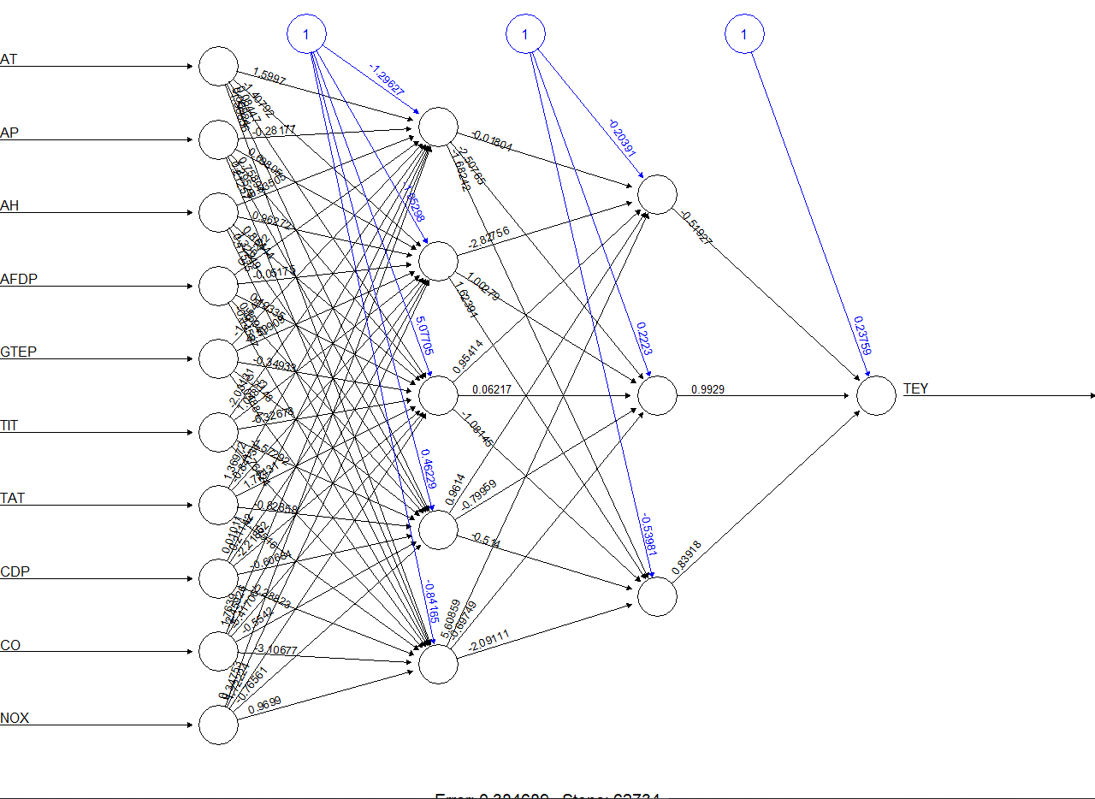

Error: 0.3, Steps: 62734

* We can keep further optimizing the model by adding layers.

**Forest Fires Solution:**

* The o/p data given here is categorical so I have used the “nnet” algorithm. After tweaking with the node size, decay and no. of iterations I have achieved a accuracy of 84.47%. Depending on what accuracy we need, we can keep further tweaking the algorithm parameters.
* Following neural network plot was achieved:

